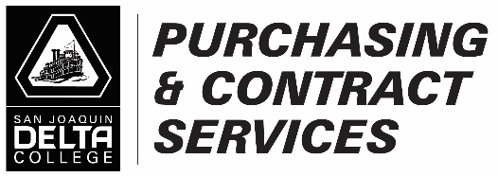__________________________________________________________________________________________________
Requisition Checklist 2025
☐ Good ☐ Service
- Goods
☐ Required number of quotes based on total amount uploaded to requisition? If not provide contract number _______________ (Co-Op, Piggyback, Education Code, Public Contract Code, Government Code or Sole Source justification.)

☐ Requisition amount matches the quote, including shipping, fees/surcharges. (Taxes don’t always match.)

☐ Supplier Contact information
Name: Click or tap here to enter text.
Email: Click or tap here to enter text.
Phone number: Click or tap here to enter text.

☐ Supplier Authorized Signer
Name: Click or tap here to enter text.
Email: Click or tap here to enter text.
Phone number: Click or tap here to enter text.

☐ New Supplier [Supplier must register prior to requisition being submitted.
https://www.deltacollege.edu/campus-offices/administrative-services/purchasing/become-supplier

☐ Board approval uploaded to requisition? Required if over the $114,800 threshold

☐ Does the supplier have a signature line (is signature a requirement) on their quote, or terms and conditions on their quote?

Note: Confirm with supplier if they will accept our signed purchase order with unsigned quote. (Preferred Method)

All non-District presented terms and conditions will need to be reviewed and approved prior to PO being issued.

B. Service
☐ Required number of quotes based on total amount uploaded to requisition? If not provide contract number _____________ (Co-Op, Piggyback, Education Code, Public Contract Code, Government Code or Sole Source justification.)
☐ Does the supplier have a signature line (is signature a requirement) on their quote, or terms and conditions on their quote?
Note: Confirm with supplier if they will accept our signed purchase order with unsigned quote? (Preferred Method). Procurement will identify the need of an agreement based on risk to the District.
☐ Service Agreement Checklist
https://app.smartsheet.com/b/form/92f62d6f91444767a0ebe2d8c5d1dc24
☐ Is a contract needed? All contracts will need to be reviewed and approved prior to PO being issued.
☐ District Template (Preferred Method) – Provide District template with applicable Scope or Work (Exhibit A) and Cost proposal (Exhibit B)
☐ Non - District Template (Non-Preferred Method) – Provide supplier agreement with Scope of Work, Terms and Conditions (T&C’s) and Cost proposal
☐ Supplier Contact information
Name: Click or tap here to enter text.
Email: Click or tap here to enter text.
Phone number: Click or tap here to enter text.

☐ Supplier Authorized Signer
Name: Click or tap here to enter text.
Email: Click or tap here to enter text.
Phone number: Click or tap here to enter text.

☐ Board approval uploaded to requisition? Required if over the $114,800 threshold

☐ Insurance uploaded to requisition?

